 초도품 검사 기록서 (AS 9102)
First Article Inspection Record (AS 9102)

AS 9102 Rev A
Form 1 : Part Number Accountability Sheet 1 of 1
1. Part Number  803W2401-003 | 2. Part Name  HINGE FTG NO2, OUTBD AILERON - LH |  | 3. Part Serial Number  공정서 task No 기입  2.3.1(동체)혹은 3.3.1(날개) |  |  | 4. FAI Report Number  QPIXXXX
5. Part Revision Level  See the attached #1 | 6. Drawing Number  See the attached #1 |  | 7. Drawing revision level  See the attached #1 |  |  | 8. Additional Changes  N/A
9. Manufacturing Process  Reference  Work order No. | 10. Organization Name  KAL-ASD  (업체명) |  | 11. Supplier Code  1699 F |  |  | 12. P.O. Number  N/A
13. Detail FAI □(Check) | Assembly FAI □ |  | 14. Full FAI □(Check) |  |  | Partial FAI □
Reason for Partial FAI / Baseline Part Number including revision Level:
Partial 일 경우만 기록
- if above part number is a detail part only, go to Field 19
- if above part number is an assembly, go to the “INDEX” section below.
INDEX of part numbers or sub-assembly numbers required to make the assembly noted above.
15. Part Number |  | 16. Part Name |  | 17. Part Serial Number |  |  | 18. Note
Signature indicates that all characteristics are accounted for; meet drawing requirements or are properly documented for disposition.
Indicate if the FAI is complete per applicable QMS: □ FAI complete □ FAI not Complete (Check)
19. Signature 검사원 이름 및 스템프 |  |  |  |  | 20. Date Form #1 작성 완료일
21. Reviewed By 품질보증 담당 이름 및 스템프 |  |  |  |  | 22. Date 품질보증 승인일
23. Customer Approval |  |  |  |  | 24. Date
F-02-351 (2) Rev. Date : 10 JUN 10
초도품 검사 기록서 (AS 9102)
First Article Inspection Record (AS 9102)

AS 9102 Rev A Sheet 1 of 1
Form 2 : Product Accountability Raw Material, Specifications and Special Process(s), Functional Testing
1. Part Number  803W2401-003 | 2. Part Name  HINGE FTG NO2, OUTBD AILERON - LH |  |  |  | 3, Part Serial Number  공정서 tesk No 기입  2.3.1(동체) 혹은 3.3.1(날개) |  |  | 4, FAI Report Number  QPIXXXX
5. Material or  Process Name |  | 6. Spec. No. |  | 7. Code |  | 8. Special Process Supplier  Code (Name, Address) |  | 9. CAV | 10. CoC Number
원자재는 Form #2에 기록함

“Spec은 PL 의 DOC LIST 참조”

11. Functional Test Procedure Number |  |  | 12. Acceptance report number, if applicable
없을 경우 “N/A” |  |  | 없을 경우 “N/A”
13. Comments 없을 경우 “N/A”
14. Prepared By 검사원 이름 및 스템프 |  |  |  |  |  |  | 15. Date Form #2 작성 완료일
F-02-351 (2) Rev. Date : 10 JUN 10
초도품 검사 기록서 (AS 9102)
First Article Inspection Record (AS 9102) Sheet 1 of 1

Attachment #1 for Form 1
Drawing Revision Status
FAI Part Number: 803W2401-003 |  |  |  | FAI Report Number: QPIXXXX
Eng Doc. No. | SHT No. | Rev. No. | ECN No. |  | Eff. From | Eff. To
803W2401-003 | 001 | NEW |  |  | K0001 | K9999
803W2401-003 | CATPART | NEW |  |  | K0001 | K9999
803W2401-003 | PL | NEW |  |  | K0001 | K9999
각 Item 별로 check하고 검사원 인장
및 날짜를 stamp
F-02-351 (2) Rev. Date : 10 JUN 10

초도품 검사 기록서 (AS 9102)
First Article Inspection Record (AS 9102)
AS 9102 Rev A
Form 3 : Characteristic Accountability, Verification and Compatibility Evaluation Sheet of
1. FAI Part Number (and Engineering Part Number)  803T1340-003 |  |  |  | 2. Part Name  RIB POST, V-TAIL - FWD, LH, VS1528 |  |  | 3. Part Serial Number  X.X.X |  | 4. FAI Report Number  QPIXXXX
Characteristic Accountability |  |  |  | Inspection / Test Results
5. Char.  No. | 6. Reference Location | 7. Characteristic  Designator | 8. Requirement | 9. Results | 10. Designed  Tooling | 11. NCR  Number | 14. Note
① ~ 은 See attached Sheet 1

N1 ~ N11 은 See attached PL

Balloon DWG 이나 PL에 기록되지 않은 사항은 입력할 것
18
All the characteristics/requirements within PL, PSDL, TSD, REP, Part Notes, CUSTOMER LETTER, Ply Group, or COP/COA should be verified individually (requirement by requirement), and then recorded respectively. Instead of direct recording in Form #3, document copy and attachment with individual requirement stamp-offs is allowed.
PL, PSDL, TSD, PSS, REP, Part Notes, CUSTOMER LETTER, Ply Group, or COP/COA의 모든 요건들은 항목별로 개별 확인 후 기록되어야 한다. Form #3에 직접 기록하는 대신, 해당 문서를 복사하여 해당 항목에 개별 인장 날인 후 첨부하는 방법이 허용된다.
Verified By: 검사원 이름 및 스템프, 날짜

12. Prepared By 검사원 이름 및 스템프 |  |  |  |  |  |  |  | 13. Date #3 작성 완료일
F-02-351(2) ) Rev. Date : 10 JUN 10
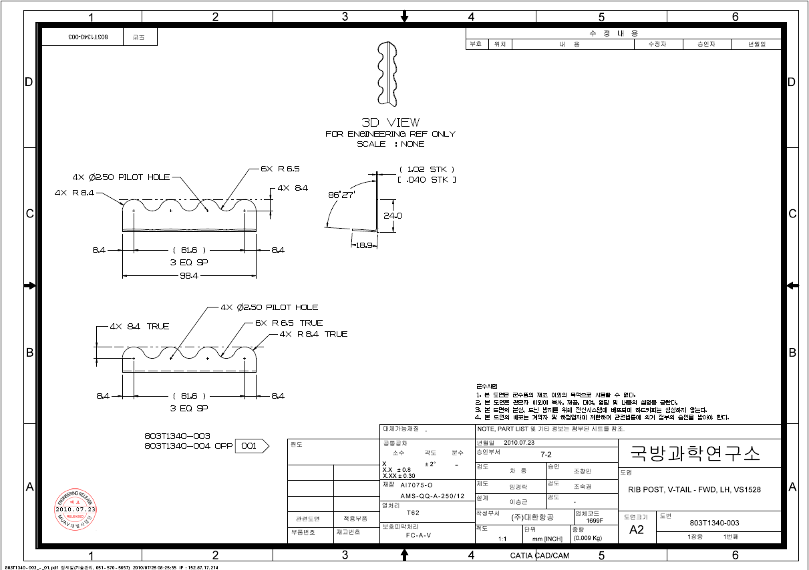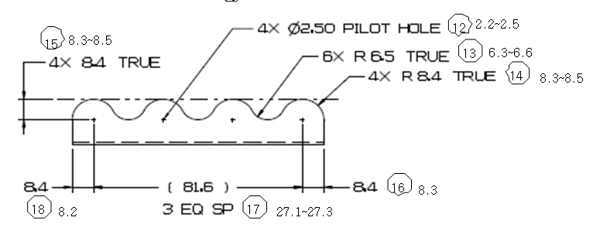
1
2
3
4
5
6
7
8
9
10
11
12
13
14
15
16
17
18
24.2
18.8
86
°
6.3~6.6
8.3~8.5
2.2~2.5
8.3~8.5
8.3
27.1~27.3
8.2
98.3
2.2~2.5
6.3~6.6
8.3~8.5
8.3~8.5
8.3
27.1~27.3
8.3
8.2
27.1~27.3
8.3
-
S/B 값 곁에 Ballon No 와Actual 값 기록함.

단, 특수 공차 적용의 경우 공차를 추가하여 기록할 것

First Article
803T1340-003
QPI XXXX
검사원 Stamp & 날짜

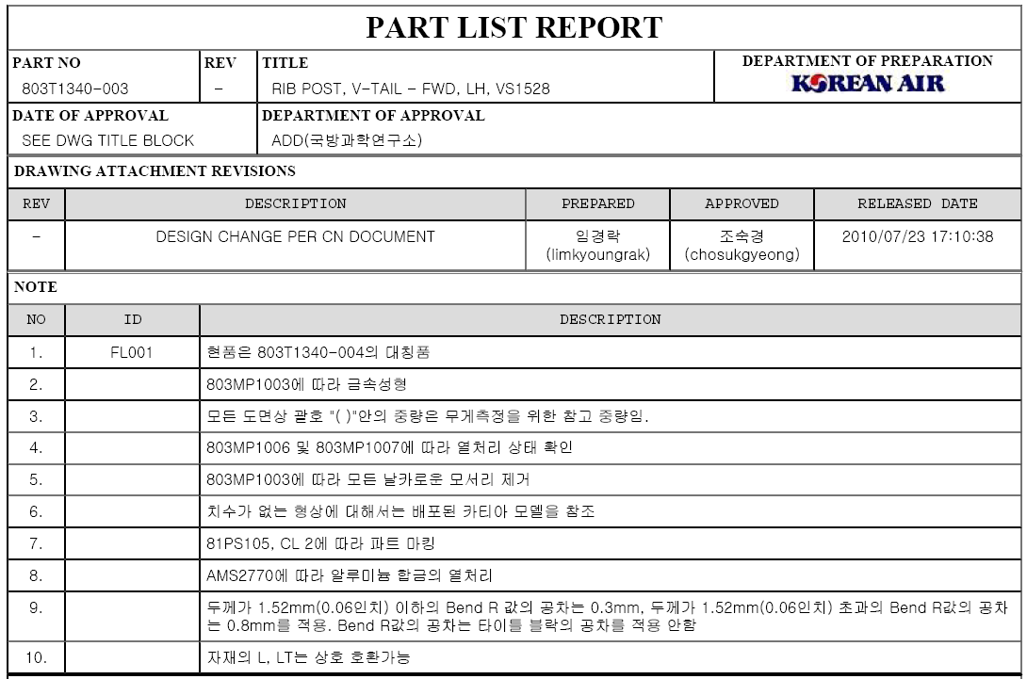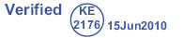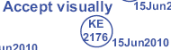
N1
N2
N3
N4
N5
N6
N7
First Article
803T1340-003
QPI XXXX
검사원 Stamp 및 날짜

First Article
803T1340-003
QPI XXXX
검사원 Stamp 및 날짜

First Article
803T1340-003
QPI XXXX
검사원 Stamp 및 날짜

